Name: Jamie Anthony Brindle
Student ID: 06352322
Title: Website Development: Online Bookshop Assignment 1 Demonstration and Testing
Teachers Area, Teacher Privileges

Teacher Login:
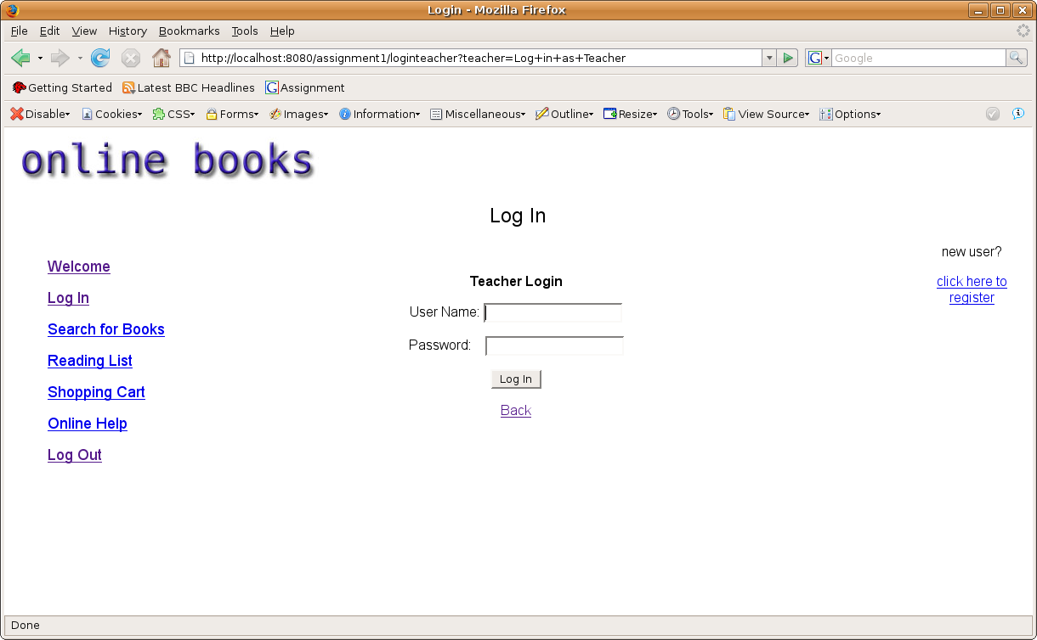
Teacher Login: Unsuccessful
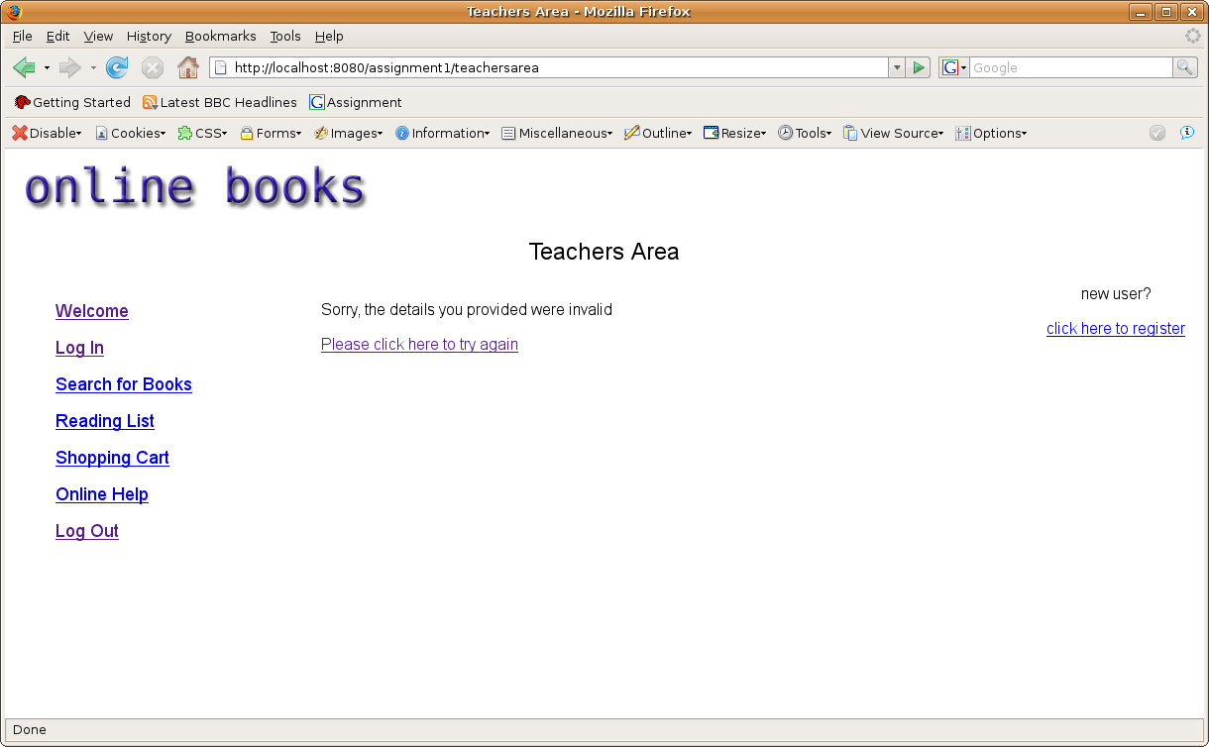
Error message appears asking the teacher to try again
Teachers Area: Successful
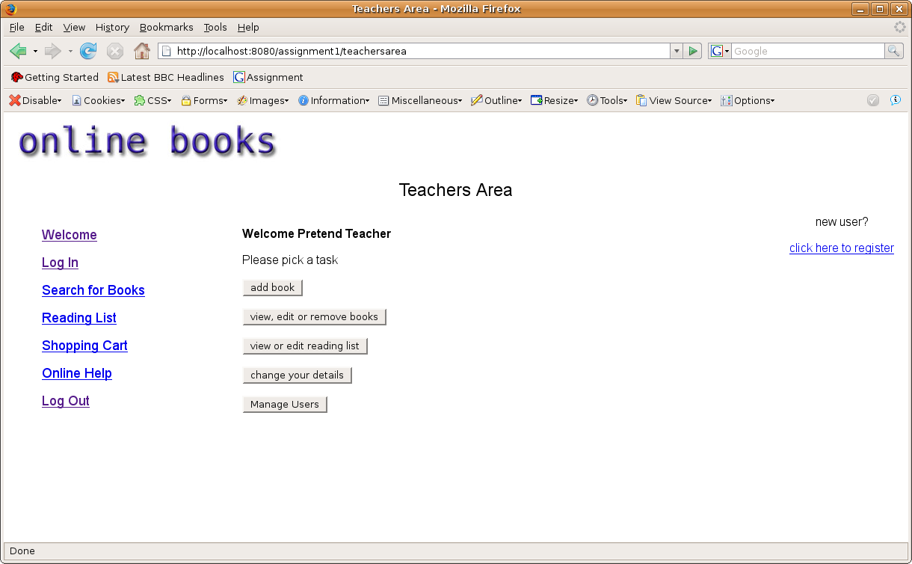
A menu appears after greeting the teacher by name and session cookies are stored, storing teacher user name, teacher password and a teacher validation cookie. The menu allows the teacher to add new books, search for books that they wish to remove, edit or add to a specific course reading list, view the reading lists which they may wish to edit, remove or add and remove courses that the specific reading lists go into, change their own details except their unique user name and manage users which includes searching users and viewing all their details including their previous orders, and removing users if they wish

Add Book: From teachers area
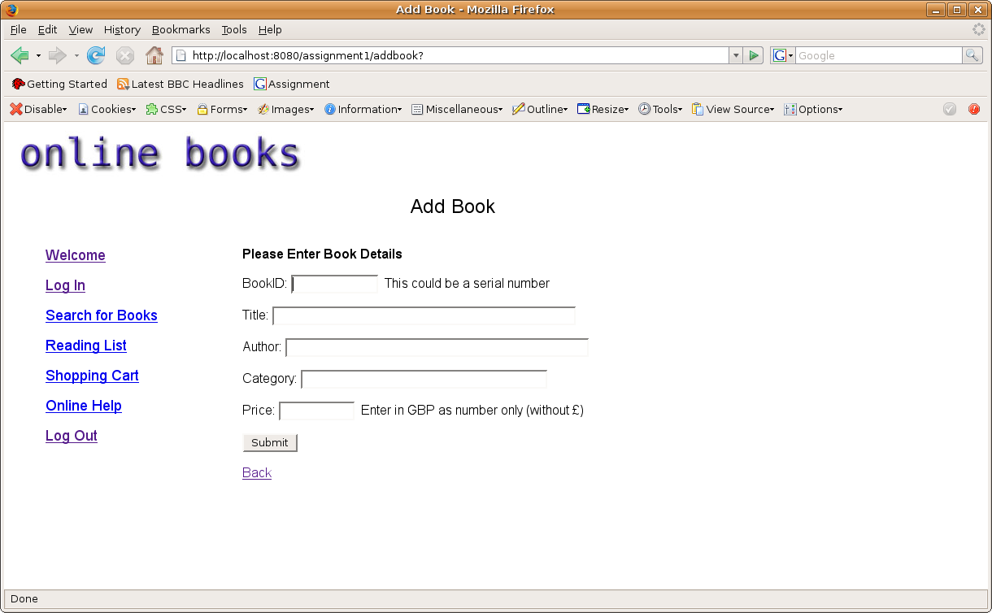
Allows teacher to enter book information to add to database
Add Book: Confirmation
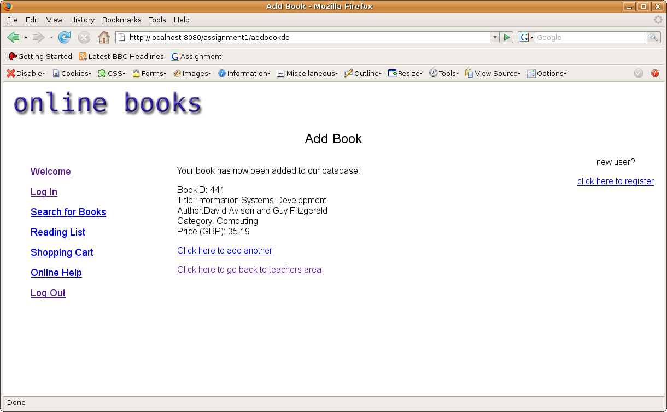
Confirmation The Book has been added to the database

Add Book: Confirmation that the book already exists on database (through bookid – this is why it's generally a good idea for the book id to be the book's serial number)
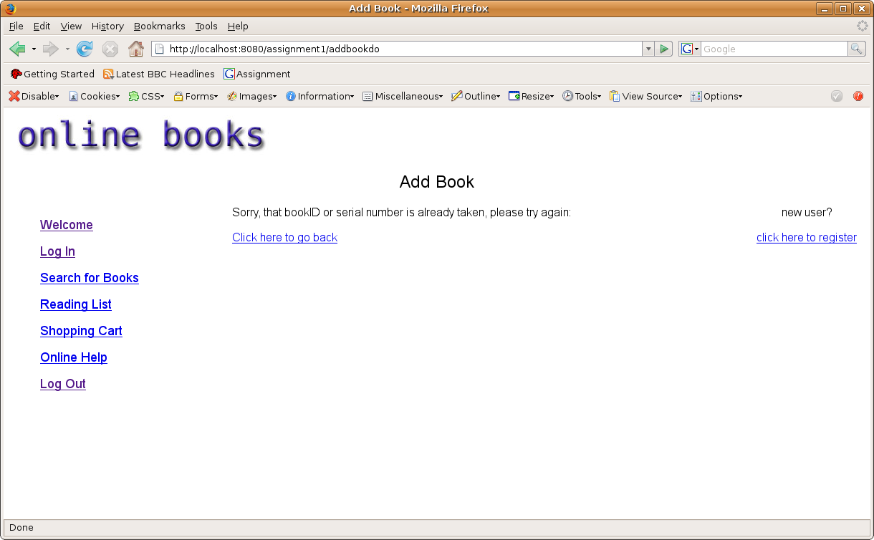
Confirmation successful

Add Book: Error occurred while trying to add book
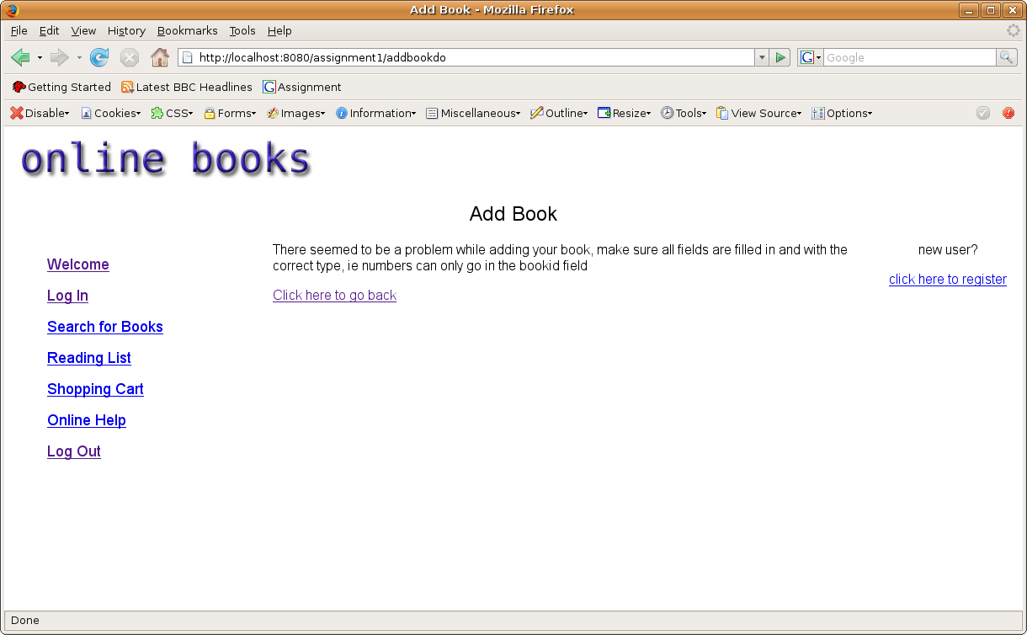
This error message appears if the user enters characters in the price field or any information that is in the wrong format for its field

Teachers Book Search: Search for book the same as a user searches for a book but teacher has more privileges
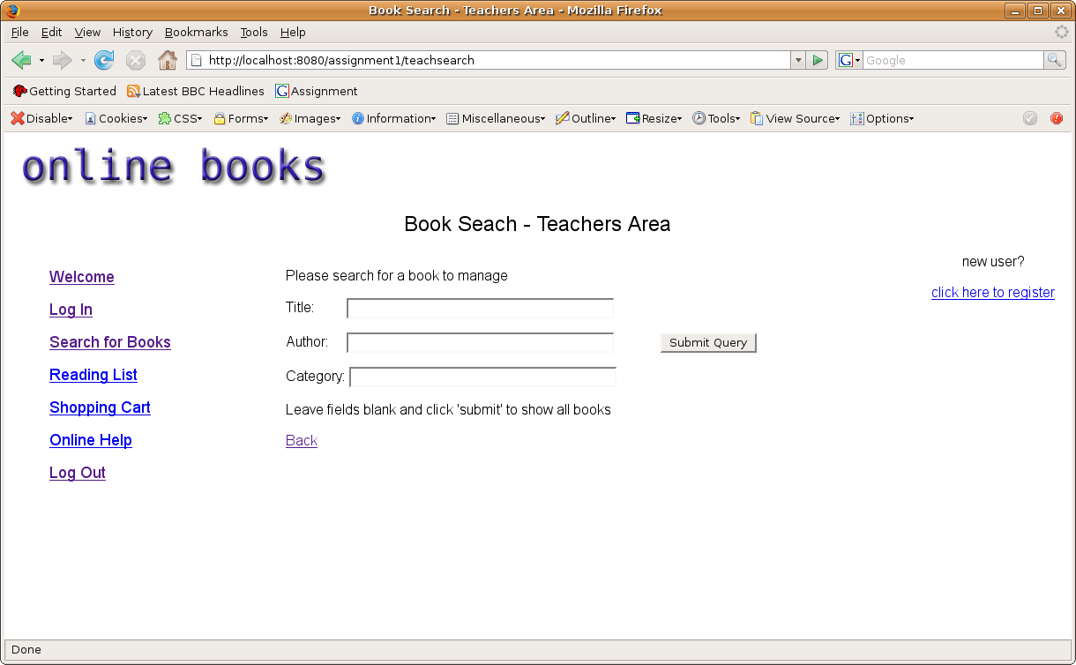
Teacher can search for books involving the very same system as user do but the results show different privileges

Book Search: Results
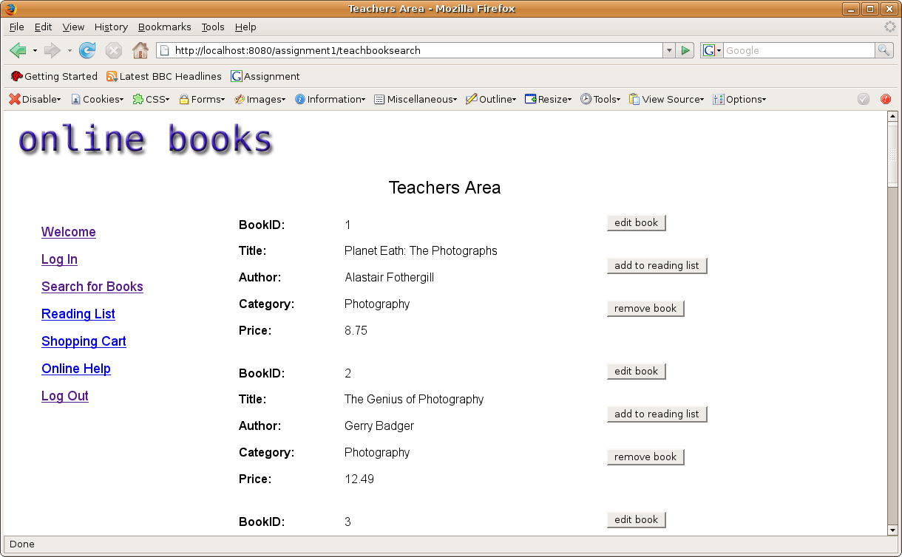
From here teachers can edit the book, add the book to a reading list or remove the book

Edit Book: From teachers book search
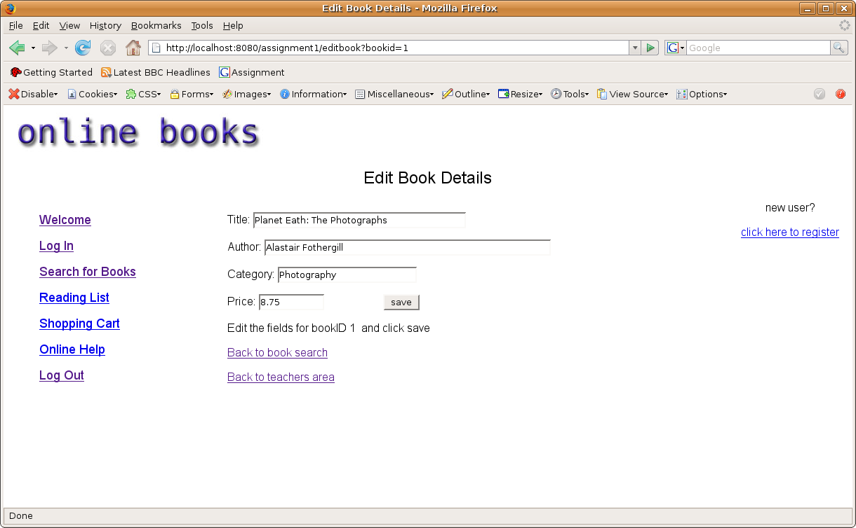
Book details are shown in editable text fields so the teacher can change the details of the book

Edit Book: Confirmation
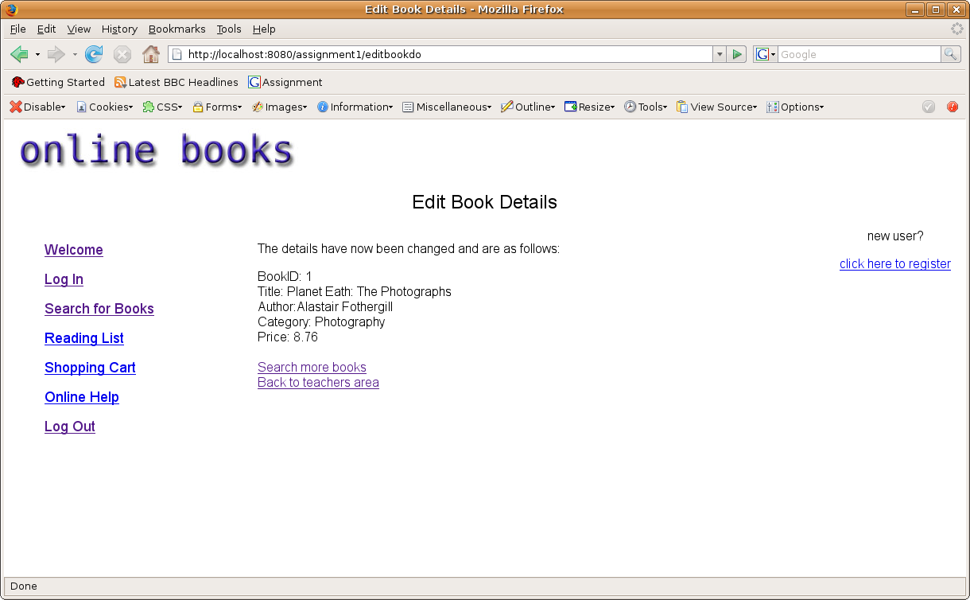
Book details have been updated

Add To Reading List: From teachers book search
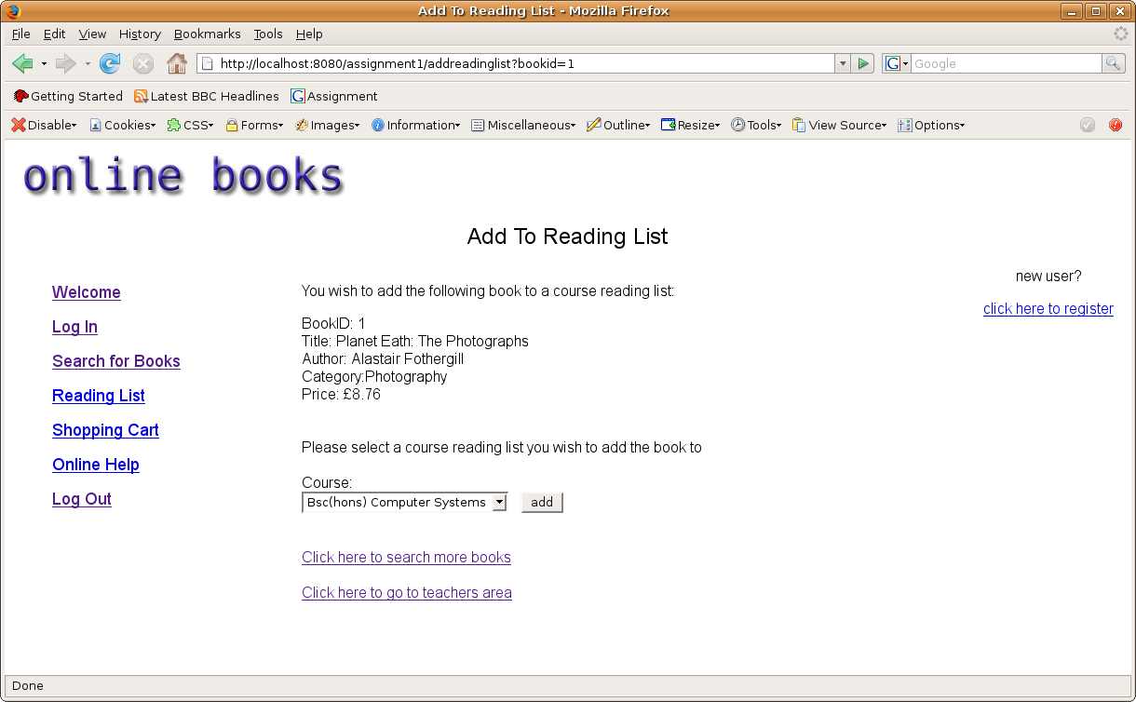
Brings up a page for the teacher select which course to add the book to it's reading list

Add To Reading List: Confirmation
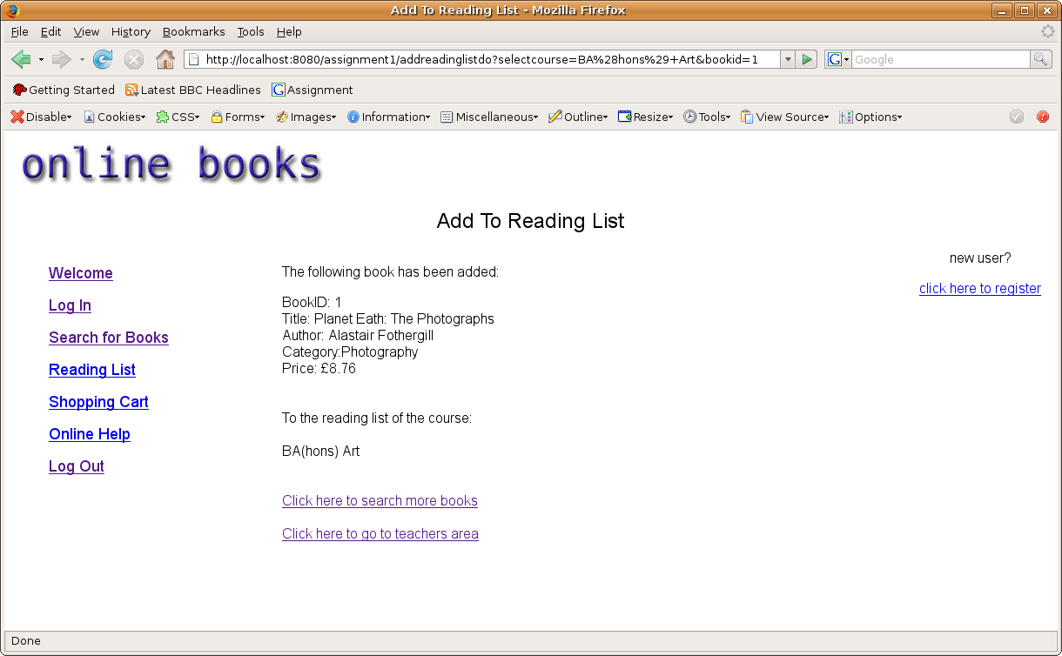
confirms the book has been added to the selected course reading list

Remove Book: From teachers book search
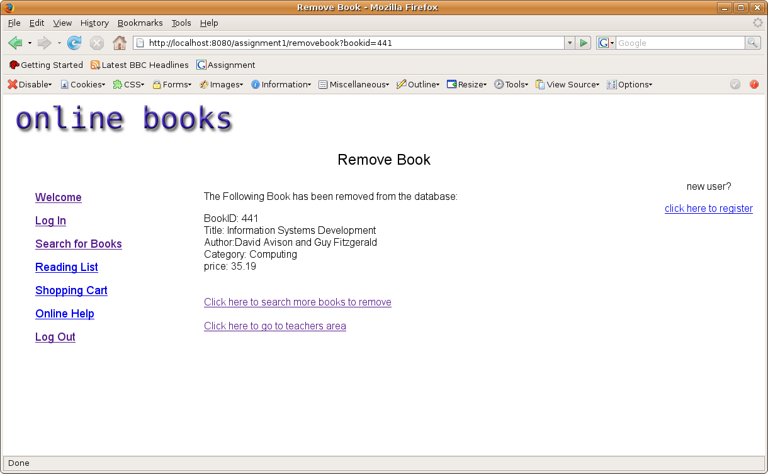
confirms the book has been removed from the database

Edit Reading List: From teachers area menu
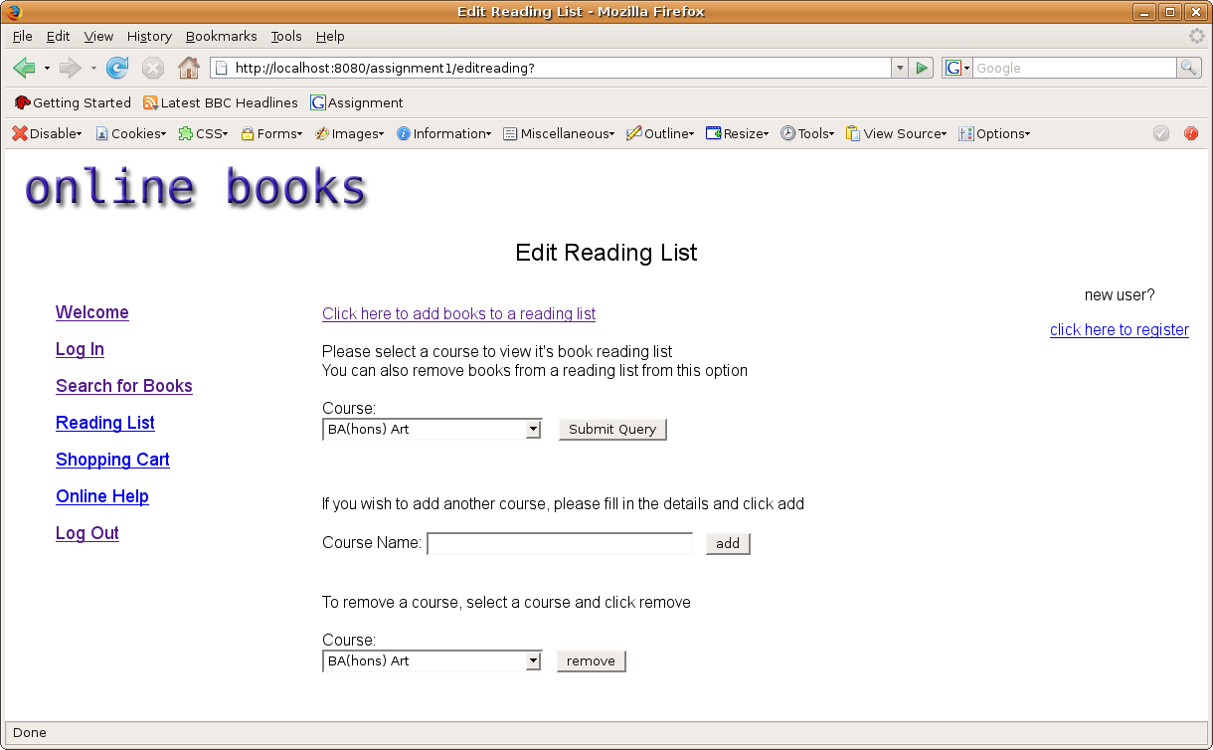
Brings up a page that includes a link for a teacher to add a specific book to a reading list, and also allows the teacher to select which course to view it's reading list and remove a specific book from a reading list (or course). Also courses can be added or removed from this area

View Course Reading List:
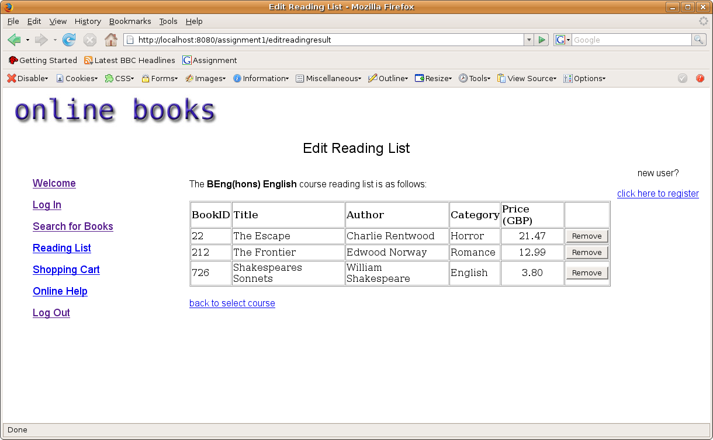
Confirms which course reading list the book belong to while showing the results and allows the teacher to be able to remove a specific book from the course reading list

Remove Book From Reading List: Confirmation
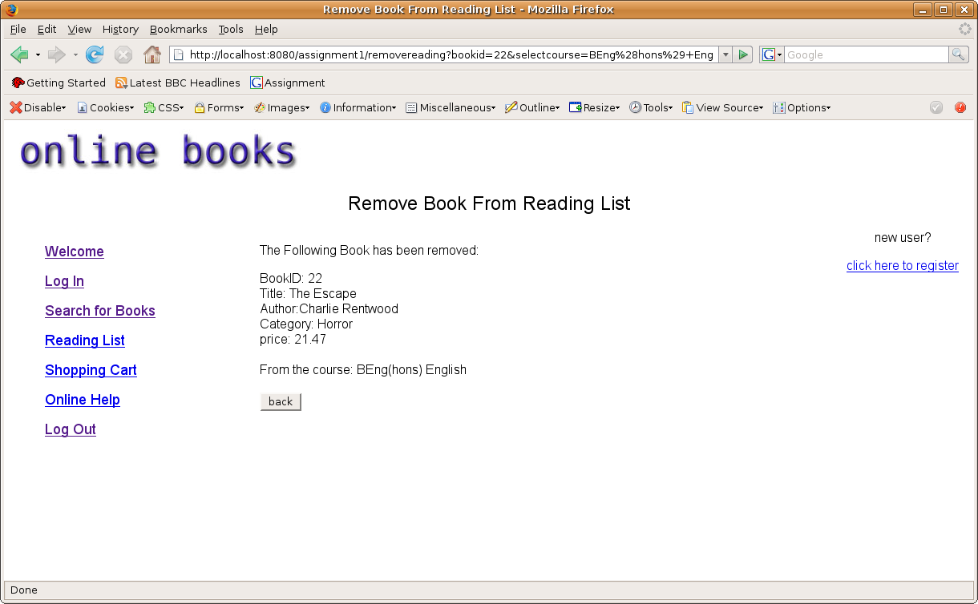
Confirms which book has been removed and from which reading list. Also allows the teacher to go back to the previous selected reading list in case the teacher want to remove more than one book from the selected reading list

Remove Book From Reading List: Back button
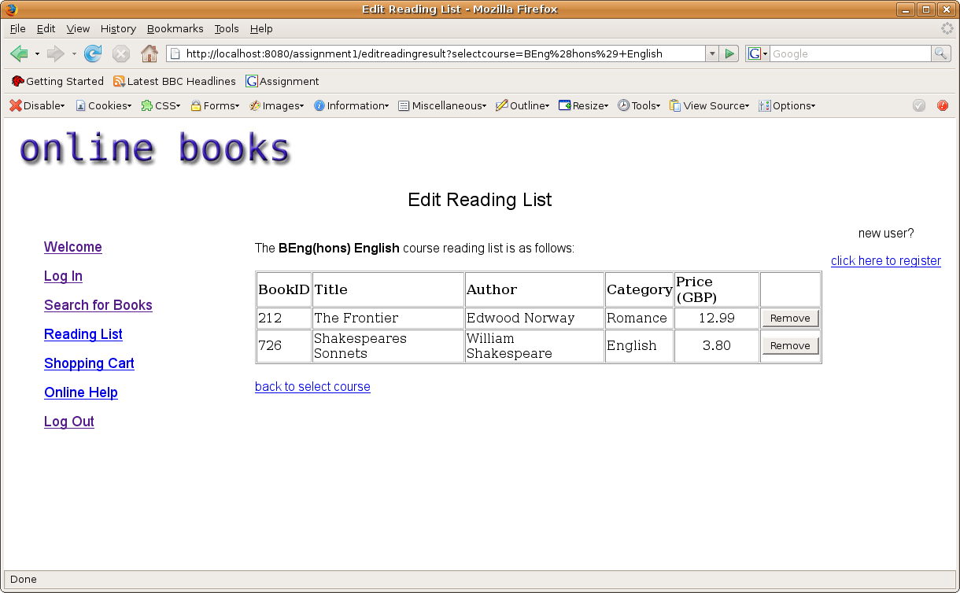
Displays reading list minus the removed book as expected

Add / Remove Course:
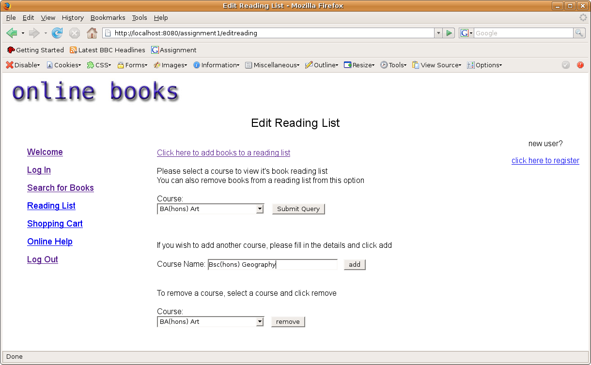
Upon clicking 'add' or 'remove' there is no confirmation page, you can simple see it in the 'course' drop down menu

Change Teacher Details:
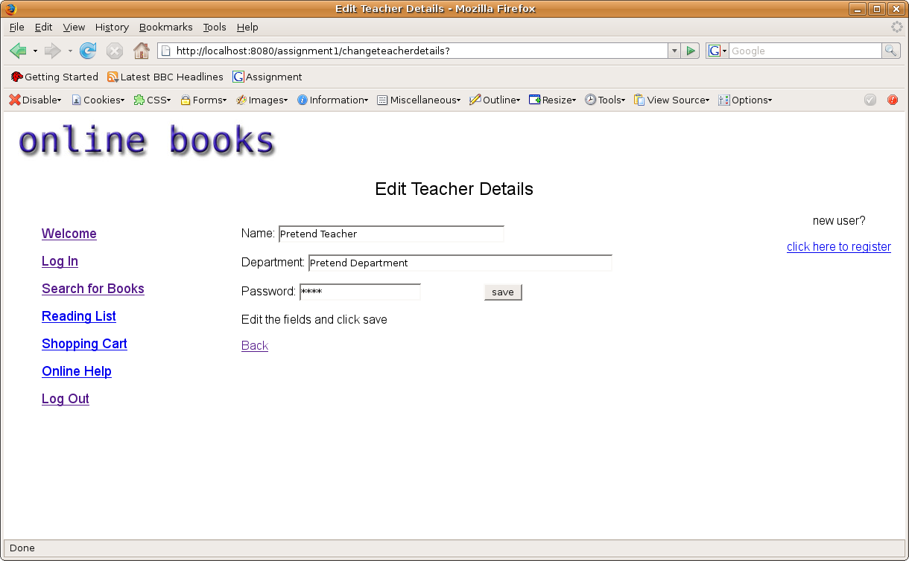
Brings up a page with editable text fields so the teacher can update their details

Change Teacher Details: Confirmation
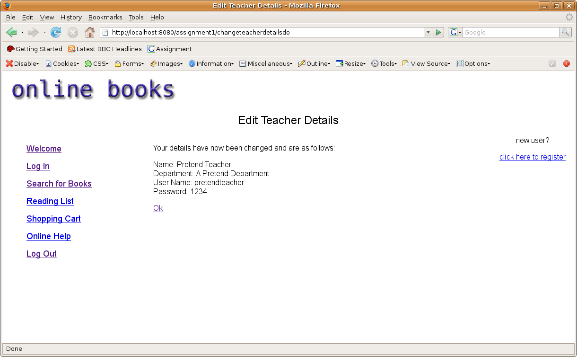
Confirmation of the teachers details being changed and database updated

Manage User: Search for students to manage
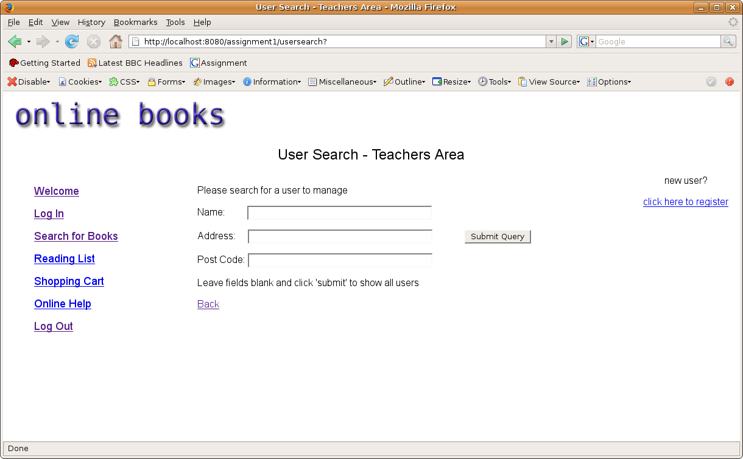
Similar to the book search method. Users can be found by entering information on one or more fields, or by leaving the fields blank can search for all users

Manage Users: Search Results (unsuccessful)
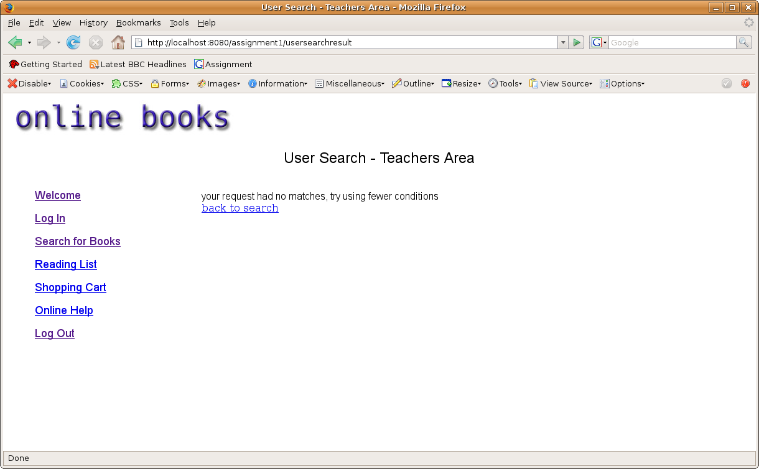
Error message appears asking the teacher to try again

Manage Users: Search Results (successful)
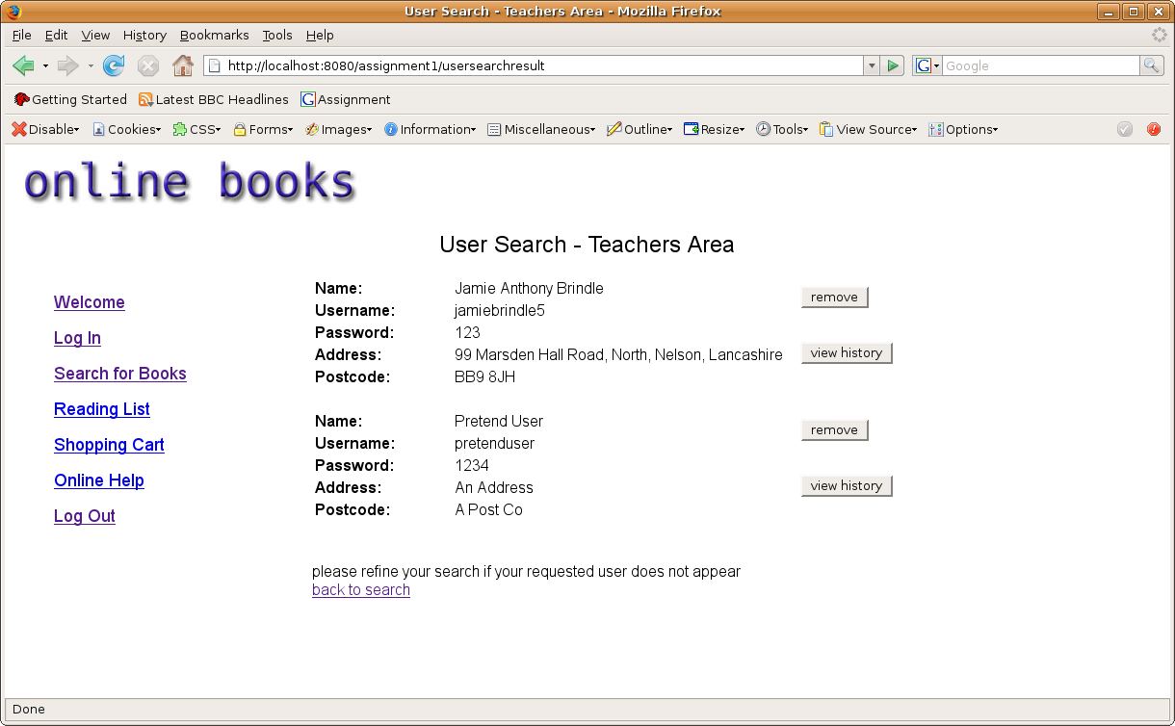
Results returned all users, and shows all the users details. The teacher can remove the user from here if they wish, or view their order history

View Order History: Of users from teachers area
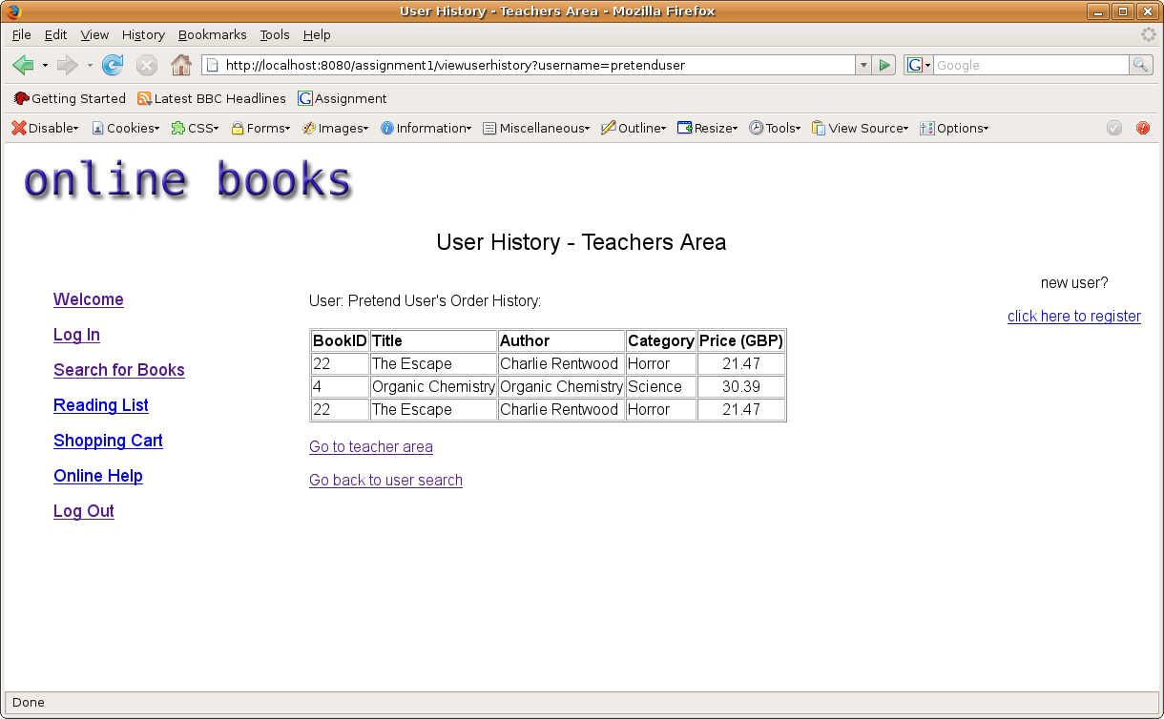
Shows users' previous orders

Remove User: From teachers area – Confirmation
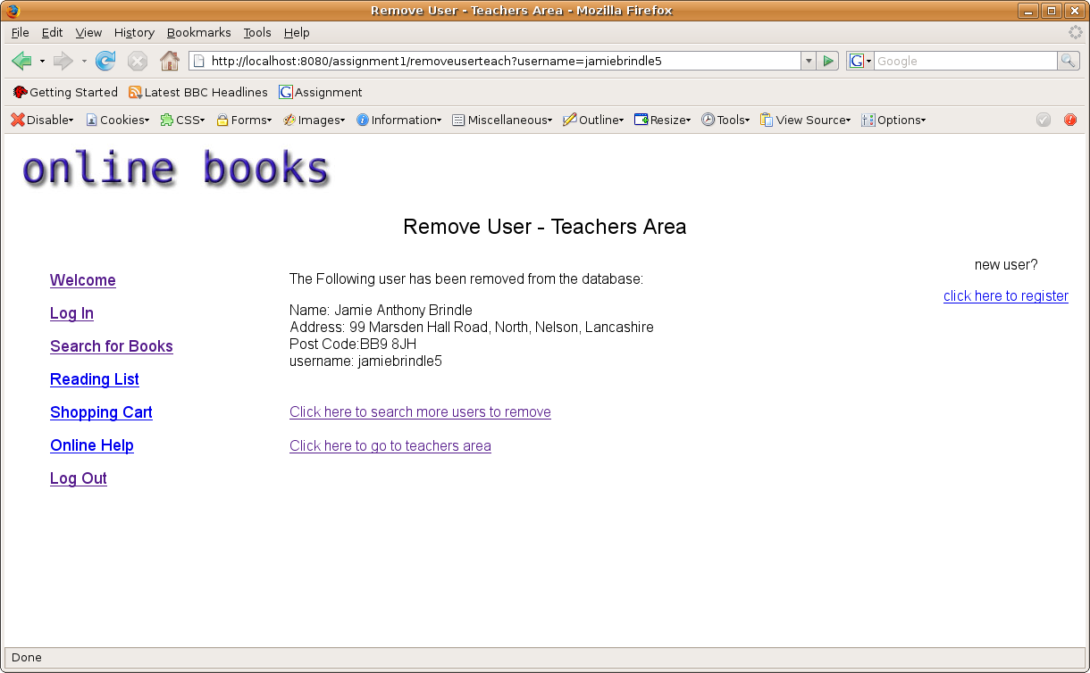
Confirms the user has been removed from the database

